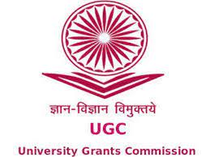 MADURAI KAMARAJ UNIVERSITY

**(*University with Potential for Excellence*)**

***Re- accredited by NAAC with ‘‘ A++’’ Grade in the 4 th cycle***

**WOMEN’S STUDIES CENTRE**

**ONE DAY INTERNATIONAL SEMINAR**

**ON**

**WOMEN AT THE FOREFRONT: INNOVATION AND EMPOWERMENT**

**Date: 23.08.2024 Time: 10.00a.m. - 1.00 p.m.**

**Venue: Online mode No.of.Benificiaries:120**

The Women’s Studies Centre, Madurai Kamaraj University, Madurai organized a one day International Seminar on the topic ***“Women at the Forefront: Innovation and Empowerment”*** in collaboration with Women’s Empowerment Cell, Nagarathinam Angalammal Arts & Science College, Madurai and TempLEyork International Academy (run by Naga Educational and Charitable Trust) on 23rd August 2024.

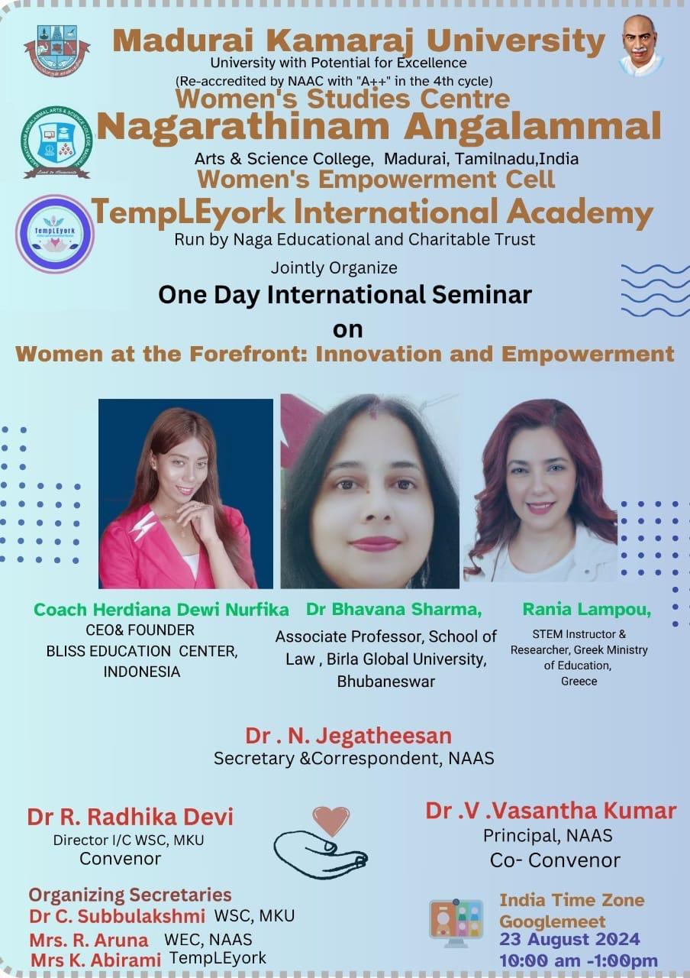

The seminar began with the welcome address by Dr.R.Radhika Devi, Director i/c, Women’s Studies Centre, Madurai Kamaraj University, Madurai. She in her welcome address welcomed Coach Herdiana Dewi Nurfika, CEO &Fonder Bliss Education Center, Rania Lampou, STEM Instructor & Researcher, Greek Ministry of Education, Greece and Dr.Bhavana Sharma, Associate Professor, School of Law, Birla Global University , Bhubaneswar the resource persons for the International Seminar.

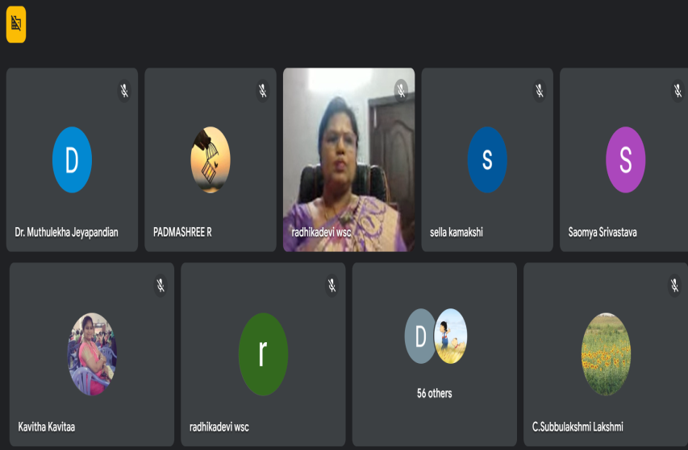

She further said that while on one hand, India has seen an increased percentage of literacy among women, and women are now entering professional fields, the practices of female infanticide, poor health conditions and lack of education still continue as a barrier for women empowerment. Even the patriarchal ideology of the home being a woman’s ‘Real Domain’ and marriage being her ultimate destiny hasn’t changed much. If one looks at the status of women then and now, one has to look at two sides of the coin, one side which is promising and the other side which is depressing. This seminar would bring out issues adding to the two sides of the coin and pave way for further insights. She concluded her speech by requesting the participants to make use of the seminar. After the welcome address the resource person, Coach Herdiana Dewi Nurfika delivered lecture on the topic “**Empowering Women: A Holistic Approach to Mind Body and Soul**”. She in her lecture told that in this interconnected world, women play a pivotal role in shaping society and their-well being for the progress of communities and nations. She also quoted advice from Audrey Hepburn like “I believe that happy girls are the prettiest girls, I am not one - in a million kind of girl, I am a once in a lifetime kind of woman”. While explaining different kind of zones in life, people who are in comfort zone wanted things to be in control, they predict future and will utilize limited opportunity and always wanted to feel safe. People who are in fear zone will give excuses, focusing only on problems, afraid of failure, will doubt his or her self, will procrastinate time. While speaking about Mind, Body and Soul she listed nine habits for better mind, body and soul. For healthy mind you should list out your thoughts that occur in your mind, limit time on social media, speak positive affirmations, for healthy body start taking morning walks, eat food consisting of whole grains and drink more water, for healthy soul start a mindfulness practice, connect with people daily, find a creative outlet.

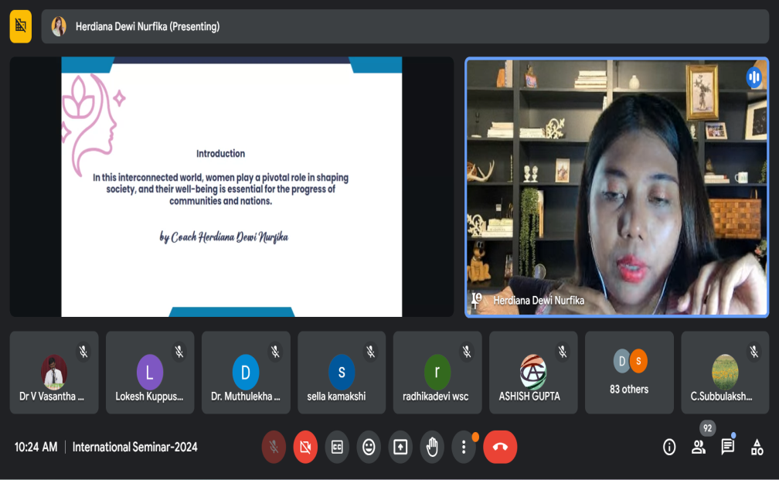

Resource Person further told that prioritizing mental health is crucial for women’s empowerment. Education is a powerful tool for women’s empowerment. Knowledge and skills are essential for breaking down barriers and achieving goals. Economic empowerment is vital for women’s well being. Women must seek opportunities for financial literacy, career advancement and entrepreneurship. For women empowerment women should prioritize self-care which includes yoga, spending time with nature etc.

Women must challenge harmful gender stereotypes that limit women’s potential and advocate for gender equality. Women must practice effective time management to balance career aspirations and family commitments. Financial literacy can help women to empower. Women must be aware of cultural norms and expectations that may hinder their progress. She in her speech spoke about Mala Yousafzai as a powerful example of women who has used her mind, body and soul to make a significant impact on the world, despite her adverse conditions she advocated tirelessly for girl’s education and human rights. Women must build a supportive community which would help them to empower. She concluded her speech by saying that empowering women is essential for creating a just and equitable society, by nurturing our minds, bodies and souls and by breaking down barriers for women. After the lecture by the Coach Herdiana Dewi Nurfika, Dr.Bhavana Sharma, Associate Professor, School of Law, Birla Global University, Bhubaneswar, gave her speech on the topic **Women Empowerment and Women Rights.** She began her speech by thanking the organizers for giving her the opportunity to share her thoughts on women empowerment. Women Empowerment is giving power to women to decide for their own lives or inculcating such abilities in them. The constitution of India has more provisions for women empowerment. The preamble of Indian constitution says that We, THE PEOPLE OF INDIA, having solemnly resolved to constitute India into a SOVEREIGN SOCIALIST SECULAR DEMOCRATIC REPUBLIC and to secure to all its citizens: JUSTICE, Social, Economic and Political; LIBERTY of thought, expression, belief, faith and worship, EQUALITY of status..

Similarly Article 14 of the Indian Constitution guarantees that all people in India are treated equally before the law and have access to equal protection under the law. It is a part of the Constitution's Part 3, which deals with fundamental rights and she also said that 15(1) of the Indian Constitution states that the state cannot discriminate against any citizen on the basis of religion, race, caste, sex, or place of birth. Article 15(2) of the Constitution of India states that no citizen can be subject to any disability, restriction, liability, or condition based on their religion, race, caste, sex, or place of birth. Article 15(3) of the Indian Constitution states that the state can make special provisions for women and children without violating the right to equality. This means that the state can pass laws that give special consideration to vulnerable groups.

Dr.Bhavana further explained about Article 16(1) of the Indian Constitution states that all citizens have equal opportunity in matters of employment and appointment to any office under the state. No citizen shall, on grounds only of religion, race, caste, sex, descent, place of birth, residence or any of them, be ineligible for, or discriminated against in respect of, any employment or office under the State. Article 21 of the Indian Constitution guarantees the right to life and personal liberty and states that no one can be deprived of these rights except in accordance with the law. The Directive Principle of State Policy protects women rights through the provisions such as Article 39A, Article 39(d),  Article 42, Article 44,. Article 243D and Article 243T. The virginity test violates right to privacy under article 21.

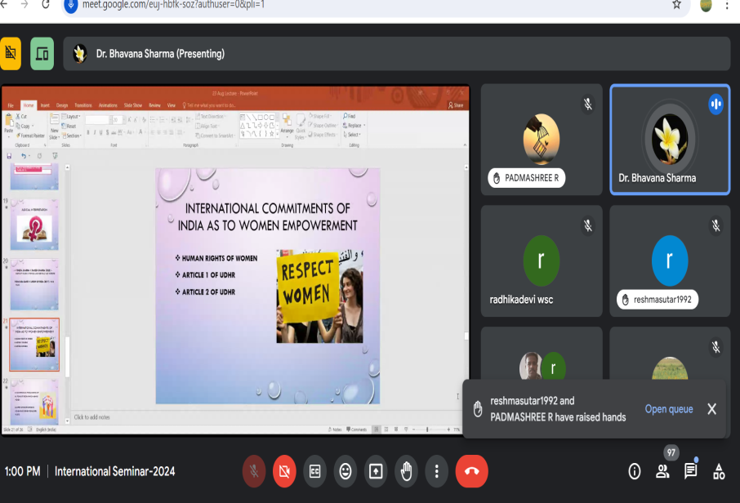

The resource person further explained about other various statutory provisions for the protection of women rights. The Bharatiya Nyaya Sanhita, 2023 replaces the Indian Penal Code, 1860 (IPC), which is the principal law on criminal offences. It provides first time community service as one of the punishments for petty offences. The offences against women and children, murder and offences against the State have been given more importance. The Bharathiya Nyaya Sanhita retains these provisions.  It increases the threshold for the victim to be classified as a major, in the case of gang rape, from 16 to 18 years of age. Dr.Bhavana while speaking about international commitment of India for Women Empowerment said that India follows Convention on the Elimination of All forms of discrimination against women. India adopted United Nations Principles on Women Empowerment established in 2010.The resource person while explaining about Government policies and schemes for Women Empowerment told about National policy for Empowerment of women in 2001. She also explained about schemes like Beti Bachao, Beti padhao, Support to Training and Empowerment Program for Women (STEP). She concluded her speech with the quote “Law is nothing unless close behind it stands a warm living public opinion”…. Wendell Philips.

After the speech by Dr.Bhavana; **Rania Lampou** STEM (Science Technology Engineering Maths) Instructor & Researcher, Greek Ministry of Education, Greece began her speech on the topic **“Women in Tech: Triumphs, Challenges, Future Directions”.** She in her speech told that empowering girls in STEM is not just about achieving gender balance it is about ensuring that diverse perspectives and experiences are well represented in these fields. Women are under represented in STEM fields comprising only 28% of female PhD students globally and 24% of the global STEM workforce. Less than 30% of researchers worldwide are women. Only 35% of STEM students globally are women and this figure drops to 28% for female PhD students.

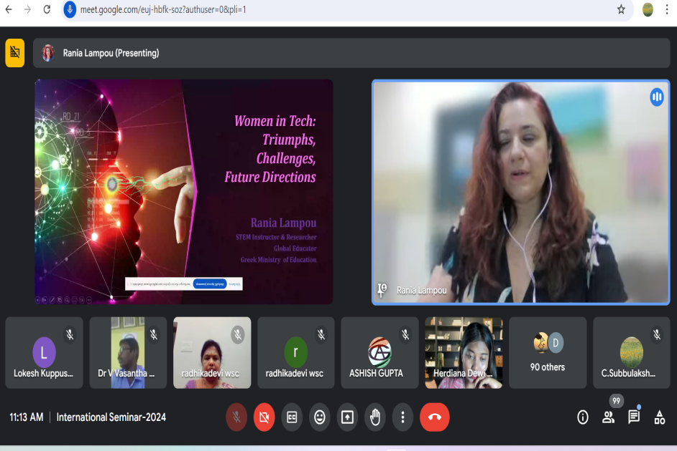

Women are also under represented in STEM leadership positions with only 24% of the global STEM workforce female. Female student’s enrolment is particularly low in ICT, Natural science, Mathematics, Statistics, Engineering, Manufacturing and Construction. Over the past fifty years women reversed the education gap and turned it to their favour. Now they earn more Graduate, Undergraduate and even more PhD Degrees than men. She further explained about women with ground breaking contributions in the tech industry as follows, Sheryl Sandberg: Tech executive and Advocate for women in leadership, Reshma Saujani: Founder of girls who code, Fei- Fei Li: AI and Machine Learning Leader, Susan Wojcicki: CEO of You Tube, Megan Smith, former U.S. Chief Technology officer, Katherine Johnson: Mathematician working with NASA, Kimberly Bryant: Founder of Black Girls Code. Ritu Karidhal Srivastava is a key member of the Chandrayaan-3 mission team and is known as the "Rocket Woman of India". She has worked for ISRO since 1997.Rania Lampou further explained about Challenges faced by women in STEM as follows; Gender stereotypes, lack of female role models, Deficiency of mentorship, Maternal wall bias, lack of recognition, low wages and low confidence. She concluded her speech by saying that to bring more women into the field of STEM gender sensitive curricula should be followed in schools. Raise public awareness about the fields of STEM, especially parents must given awareness about the field. Expand after-school and summer STEM opportunities for girls. We should emphasize strong and visible role models of women in science fields to students. Reduce the gender gap in the field of STEM by conducting regular pay audits in the institution. When more women are brought into the field of STEM women would be empowered which will lead to a progressive society. After the speech by Rania Lampou the feedback session began. In the feedback session the participants shared their views about the seminar and told that the seminar was highly informative. The seminar came to an end with the vote of thanks by Dr.V.Vasantha Kumar, Principal Nagarathinam Angalammal Arts and Science College. He thanked each and every speaker for sharing their valuable information for making this International Seminar a grand success and he also said that through this seminar participants gained more knowledge regarding the legal safe guards for women, valuable contributions of women in Science and Technology and also the participants gained knowledge on barriers that women face today.

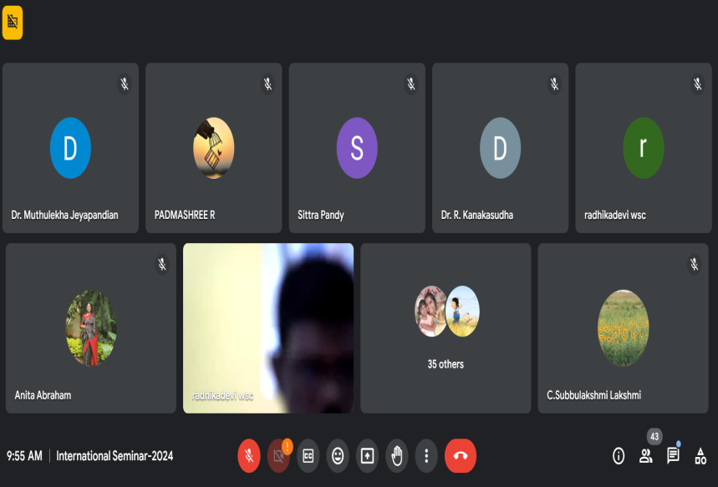

The Principal further said that the participants through this seminar learned the way to overcome the barriers faced by women. He also said that the participants got information about how Women Empowerment make a path to Innovative World. He finally thanked one and all for spending their valuable time in participating in the International Seminar and making the seminar a great success.